***Sources that I have cited:***

1. ***Texas Department of Criminal Justice*** *— "Executed Offenders." This is the primary dataset used for inmate last words.*
2. ***Ward, Laura*** *— Famous Last Words: The Ultimate Collection of Finales and Farewells. This book provides a compilation of last words from various notable figures.*
3. ***Marvin, Frederic Rowland*** *— The Last Words (Real and Traditional) of Distinguished Men and Women. Another source of historical last words from prominent individuals.*
4. ***Bisbort, Alan*** *— Famous Last Words: Apt Observations, Pleas, Curses, Benedictions, Sour Notes. This book includes a wide range of last words with emotional depth, from pleas to curses.*
5. ***Hirschmüller, Sarah, and Boris Egloff*** *— "A Focused Review of Language Use Preceding Death by Execution." This study examines the emotional content in the last statements of Texas death row inmates.*
6. ***Foley, S. R., and B. D. Kelly*** *— "Forgiveness, Spirituality and Love: Thematic Analysis of Last Statements from Death Row, Texas (2002–17)." This study focuses on themes in inmates' last statements, such as love and spirituality.*
7. ***ebemunk (GitHub)*** *— Last Words Project. This GitHub project analyzed last statements of executed inmates, using data visualization and sentiment analysis tools.*
8. ***Guthke, Karl S.*** *— Last Words: Variations on a Theme in Cultural History. This book explores the cultural significance and themes in the final words of notable individuals.*
9. ***Kniffin, Kevin M., and Brian Wansink*** *— "Death Row Confessions and the Last Meal Test of Innocence." This study examines the last statements and meal choices of death row inmates to find potential indicators of guilt or innocence.*
10. *Brahms, William B. Last Words of Notable People: Final Words of More than 3500 Noteworthy People Throughout History. Annotated edition, Reference Desk Press, Inc., 2012. ISBN-13: 978-0976532583*
11. *Ashton, Jackson. “People’s last words are often these 4 phrases: What they teach us about living happy, meaningful lives, from an oncologist.” CNBC, 31 May 2024, www.cnbc.com/2024/05/31/phrases-that-are-often-peoples-last-words-says-doctor-what-we-can-learn.html.*
12. *Mental Floss. "65 People and Their Famous Last Words." \textit{Mental Floss}, 12 Oct. 2023,\url{https://www.mentalfloss.com/article/58534/64-people-and-their-famous-last-words}. Accessed 30 Oct. 2024.*

*not yet used*

*\cite{lecomte1969}*

*\cite{fattizzo2024}*

*\cite{sexton2012}*

*\cite{kelly2018}*

*Introduction and Research Questions*

The final words spoken by an individual before death carry a profound significance, often encapsulating the culmination of their experiences, beliefs, and emotions. This project seeks to explore the psychological and emotional dimensions reflected in the last words of executed prisoners compared to notable people. In this study, executed prisoners refer specifically to individuals who have been sentenced to death and subsequently executed as a result of being convicted of serious crimes. These individuals have spent time on death row, where they await the culmination of their legal sentence through capital punishment.

Notable people in our study refer to well-known individuals who have made significant positive contributions to society, leaving a lasting impact through their achievements, values, or ideas. These individuals are often recognized for their leadership, creativity, or humanitarian efforts, and their influence extends beyond their lifetime, shaping cultural, social, or political landscapes in meaningful ways. The primary dataset for our study is the "Death Row Information" table from the Texas Department of Criminal Justice, containing detailed last statements from inmates. The dataset for notable people comprises a curated collection of notable figures' last words, sourced from historical records and web scraping from reputable sources.

Research shows that deathbed expressions commonly include themes of love and forgiveness, as noted by Dr. Mukherjee, who observed that phrases like “I love you” and “Forgive me” are prevalent \cite{ashton2024}. This observation aligns with findings in psychological studies, suggesting that final statements are often shaped by a universal pursuit of emotional resolution. Integrating these broader insights helps contextualize the sentiment and subjectivity analyses of inmates' and notable figures' last words.

We used Python-based Natural Language Processing (NLP) tools to analyze these last statements, exploring the emotional and psychological tones expressed by individuals confronting mortality. This approach offers a unique perspective, providing deeper insights into their final reflections. Through the use of text mining techniques, including sentiment and word frequency analysis, patterns were discovered that reflect how an individual’s life experiences and the nature of their death shape their final words.

Our study seeks to answer following research questions:

* What are the prevalent psychological themes (e.g., guilt, acceptance, regret) found in the last words of executed prisoners versus notable figures?
* How do emotional expressions differ between these two groups based on the context of their lives and deaths?
* Are there common linguistic patterns that suggest broader philosophical or cultural differences in how these individuals confront mortality?
* While the initial focus is on broader thematic comparisons, the research questions may evolve as analysis deepens and specific patterns emerge.

Based on prior research, we hypothesize that final words reveal distinct thematic and emotional patterns. For instance, executed prisoners’ statements are expected to focus on personal relationships, forgiveness, and closure, whereas notable figures’ statements may reflect broader philosophical or existential reflections. To analyze these themes and address our research questions, we applied NLP techniques such as sentiment analysis, subjectivity scoring, and word frequency analysis, providing a unique view into how last words encapsulate personal values and life experiences.

*Background/Related Work*

There has been many studies and research done exploring the language and emotional content of final words, particularly those of executed inmates. A study by Hirschmüller and Egloff (2018) highlights that the final statements from Texas death row inmates often reflect more positive emotions - with themes of love, spirituality, and social connection. A second study by Foley and Kelly (2018) observed a decrease in requests for forgiveness over time and found consistent themes of love, spirituality, and regret in the final statements of prisoners. Both studies by Foley and Kelly and Hirschmüller and Egloff reveal a recurring presence of positivity in the final words of prisoners. Another notable analysis on GitHub examined 454 last statements of executed inmates on Texas' Death Row. The study, conducted by ebemunk (2021), utilized the TDJC Death Row Information dataset and was processed using JavaScript (JS) and TypeScript (TS). The analysis identified patterns in last words, focusing on themes such as love, spirituality, and regret, using techniques like sentiment analysis, topic modeling, and word frequency analysis to reveal expressions of acceptance or denial of guilt.

Research on notable last words outside the correctional context often focuses on figures of historical or cultural significance. Collections, such as those presented by *Mental Floss*, offer a range of expressions—from humor to deep reflection—providing insight into how public figures confront mortality \cite{mentalfloss2024}. This context aligns with works like Marvin’s *The Last Words (Real and Traditional) of Distinguished Men and Women* and Guthke’s *Last Words: Variations on a Theme in Cultural History*, illustrating varied emotional responses in final statements\cite{marvin1901}\cite{guthke1992}.

Building on these insights, this study uses NLP tools to analyze both sentiment and subjectivity, enabling a thematic comparison across groups. We apply sentiment analysis, topic modeling, and word frequency analysis to reveal recurring and unique themes, such as spirituality, family connection, or existential reflection, showing how each group’s context influences their expressions. Our approach extends past studies by contrasting two distinct populations and examining whether context affects emotional tones in final statements.

Our project features meaningful visualizations built with Python's Matplotlib library. By using Python-based tools like NLTK and SpaCy for text mining, the analysis allowed for flexible exploration of emotional content and word frequency patterns. This approach demonstrates how Python-based NLP libraries can be used to effectively analyze and visualize final statements and enables a deeper understanding of the emotional and linguistic nuances in the data. Our findings are consistent with prior studies, such as those by Hirschmüller and Egloff (2018) and Foley and Kelly (2018), which also observed recurring themes of spirituality, love, and regret, underscoring a persistent presence of positivity even in the final moments of individuals.

Common NLP techniques used in previous studies include sentiment analysis, topic modeling, and clustering to identify underlying themes and emotional trends. For instance, Kniffin and Wansink's (2014) study combined sentiment analysis of death row inmates' final statements with behavioral data like last meal requests to get conclusions about innocence and guilt. The use of similar techniques in our own study will help us look at the nuanced comparison of emotional expressions between executed prisoners and notable people. This provides insights into the psychological differences in how individuals confront mortality. Additionally, the final words spoken before death often encapsulate the culmination of a person’s experiences, beliefs, and emotions, offering an important life lesson.

*Data Cleaning Process*

We started our project by gathering useful data that are relevant to our project. As our goal of the project is to compare last words spoken from notable people and executed inmates, we gathered many primary sources. Our primary sources included records from the Texas Department of Criminal Justice, where inmates' last statements are publicly available, along with other sources like books and Wikipedia entries that document notable people’s final words. These diverse sources laid the foundation for our analysis, but also required substantial data processing to ensure uniformity and accuracy.

To prepare the data for analysis, we employed a series of pipelines. Given that some of the data was only available in PDF format, we used the `pypdf` library to extract text. Since the PDF contained last words of notable figures, extracting clean text required specific handling to filter out formatting issues. We used regular expressions (regex) to focus on isolating the actual quotes and their translations, ensuring the extracted data contained only the meaningful content needed for analysis.

For the inmate data, we implemented web scraping directly from the Texas Department of Criminal Justice website. Our python script navigated through the listed inmate pages, capturing the paragraphs that contained their final statements. This data was already in English, eliminating the need for translation. To maintain a consistent format across datasets, we stored the extracted last words in a unified Pandas DataFrame under a common column labeled ‘Last Words.’ This uniform column structure simplified further analysis and ensured that both datasets were comparable.

Our data sources include publicly available records from the Texas Department of Criminal Justice for executed prisoners and a curated dataset from reputable sources for notable figures. **These datasets required extensive cleaning to ensure consistency and reliability in the analysis.**

* **Text Extraction and Error Correction**: We used the pypdf library for PDF text extraction of notable figures’ last words, applying regex filters to isolate relevant content. Errors introduced by OCR were addressed with custom regex patterns, correcting common issues such as broken characters and split words (e.g., merging “deci-sion” to “decision”). Inmate data collected via web scraping was parsed with BeautifulSoup to remove HTML tags and special characters.
* **Null Value and Consistency Checks**: We standardized null values by consolidating multiple representations (e.g., "None," "N/A") and ensured consistent formatting by merging broken words, removing extraneous spaces, and converting all text to lowercase.
* **Stop Words and Tokenization**: Using NLTK, we removed standard English stop words, along with context-specific words like “last” and “word,” to reduce noise. Text was tokenized to retain only alphabetic tokens, enhancing the quality of thematic analysis.

**These data cleaning techniques were carefully documented to enhance transparency and reproducibility, allowing future researchers to replicate our methodology and validate findings.**

During the data cleaning phase, we encountered several challenges. The notable people's dataset contained errors from the PDF extraction process, such as misinterpreted characters (e.g., “/v” instead of a capital “N”), broken words, and irregular spacing. We addressed these issues using regex-based filters, merging broken words and removing unnecessary spaces. For example, hyphenated terms split across lines like “deci-sion” were corrected to read as “decision.” Additionally, we standardized spaces and removed leading or trailing whitespace. Specific regex patterns helped identify and extract relevant quotes, targeting phrases like “Last Words” and text wrapped in double quotes. This allowed us to minimize irrelevant content while retaining the integrity of the last words. Translations were separated from the original quotes, preserving the distinction between them.

The inmate data had its own set of inconsistencies, primarily in the form of various representations of null values (e.g., "None," "None provided," "N/A"). To standardize this dataset, we created a list of known null values and removed corresponding entries. We also cleaned the HTML output from the web scraping process using the BeautifulSoup library, which stripped tags and decoded special characters. This produced a clean set of last statements that was ready for analysis.

We utilized a range of NLP techniques to analyze the final words, each selected for its relevance to understanding emotional and psychological content. This study’s core methods include:

* **Sentiment and Subjectivity Analysis**: Sentiment analysis was conducted using the SpacyTextBlob library, which measures both polarity (emotional tone) and subjectivity (personal bias) of statements. Polarity scores range from -1 (negative) to +1 (positive), providing insight into each group’s emotional tendencies.
* **Word Frequency and Unique Word Analysis**: We calculated word frequencies for each group to compare vocabulary patterns. This analysis highlights common themes such as notable figures’ focus on existential terms like “farewell” and “duty,” versus inmates’ emphasis on personal relationships, using words like “love” and “forgive.”
* **Thematic Analysis with Topic Modeling**: Topic modeling helped identify recurring themes, such as spirituality or familial love, allowing for deeper psychological insights into each group’s approach to mortality.

**The chosen tools and configurations in Python (e.g., SpaCy, NLTK) provided flexibility in analyzing thematic elements while ensuring minimal noise interference. These techniques allow for both quantitative and qualitative exploration, directly addressing our research questions.**

Once the data was cleaned, we moved to text preprocessing. Using the Natural Language Toolkit (NLTK), we tokenized the text by splitting it into individual words, converting all words to lowercase for uniformity, and removing common English stop words, along with custom stopwords like “last” and “word.” We retained only alphabetic tokens, eliminating numbers, punctuation, and special characters to reduce noise and improve the quality of our analysis.

In order to have consistency across our datasets, we checked for and removed duplicate entries that could skew results. This validation step ensured that only complete and accurate quotes were included in the analysis. We then aggregated the cleaned data, converting the text into single strings for each group (notable people and inmates), preparing it for frequency and sentiment analysis.

For the frequency analysis, we identified the most commonly used words in each group, providing insights into the vocabulary patterns of notable figures versus executed inmates. Sentiment analysis, conducted using the SpacyTextBlob library, measured both the polarity (positive or negative tone) and subjectivity (degree of personal bias) of the last words. This analysis offered deeper insights into the emotional tones of each group’s final statements.

To further explore differences between the groups, we identified words unique to each dataset, revealing distinct thematic elements in the last words of notable people versus inmates. By implementing these comprehensive data processing steps, we ensured that our analysis was based on accurate, relevant, and well-structured data, providing a solid foundation for meaningful comparisons of the two groups’ final expressions.

*Exploratory Data Analysis*

Our dataset includes the last words of two distinct groups: notable people from history and inmates on death row in Texas. The collection of notable individuals spans from political leaders, philosophers, to cultural icons. The inmate dataset, recorded by the Texas Department of Criminal Justice, captures the final statements of those confronting execution. Both groups’ final words provide unique insights into how people approach mortality.

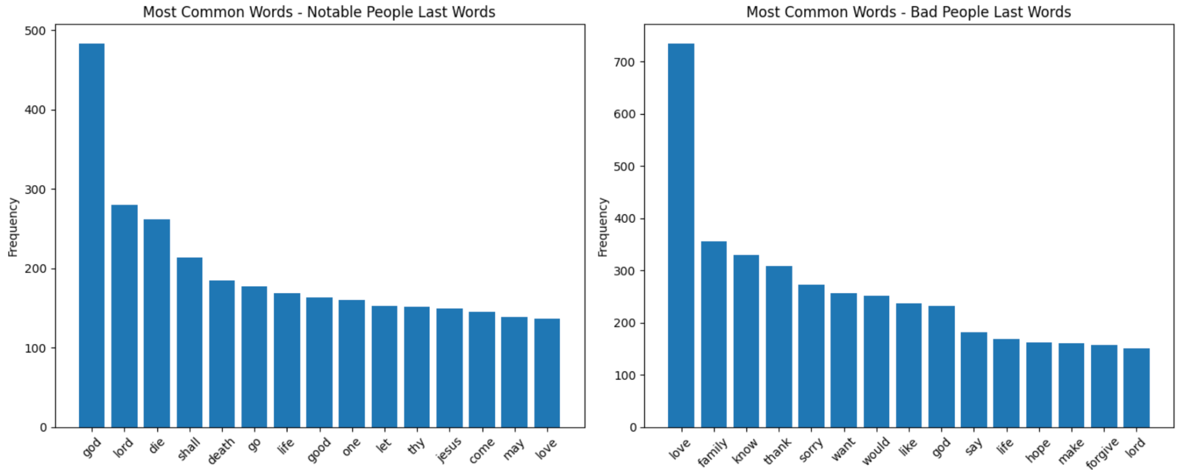

We used word frequency visualizations to highlight thematic contrasts in each group’s final expressions. Through bar charts, we visually compared the most common words in each dataset, making these thematic differences in tone and focus more apparent. In the last words of notable people, terms like “god,” “lord,” “die,” “death,” and “life” frequently appear, suggesting that their focus is often existential. These words reflect a tone of philosophical or religious reflection, likely influenced by the public nature of their lives. On the other hand, the most frequent words in inmates’ last words are “love,” “family,” “sorry,” “thank,” and “forgive.” These terms emphasize inmates’ focus on personal relationships, regret, and pleas for forgiveness, revealing a more intimate and emotionally charged context.

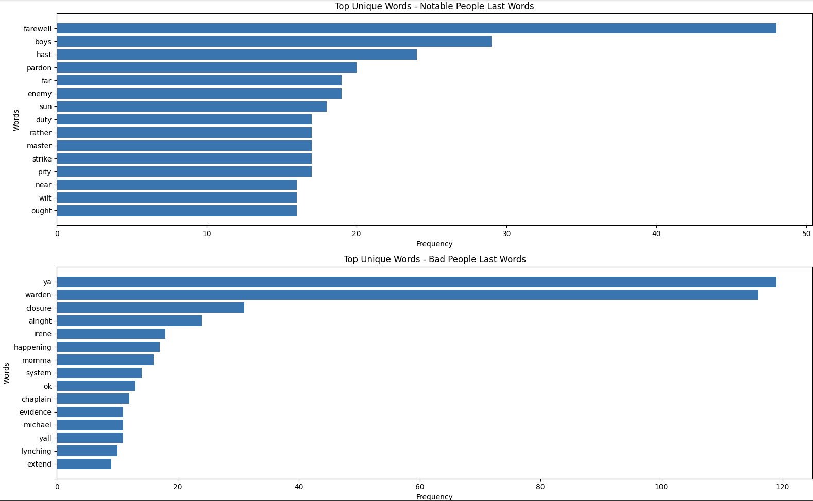

The analysis also examined unique words within each dataset, highlighting distinctive contexts in each group’s final words. For example, notable people’s last words include terms like “farewell,” “duty,” and “enemy,” conveying a formal tone consistent with their public-facing lives. In contrast, inmates’ unique words, such as “warden,” “system,” “momma,” and “lynching,” reveal references to prison conditions, personal relationships, or social commentary. Visualizations through bar charts helped highlight these distinct structural elements, visually displaying how each group’s language aligns with the unique circumstances surrounding their deaths.

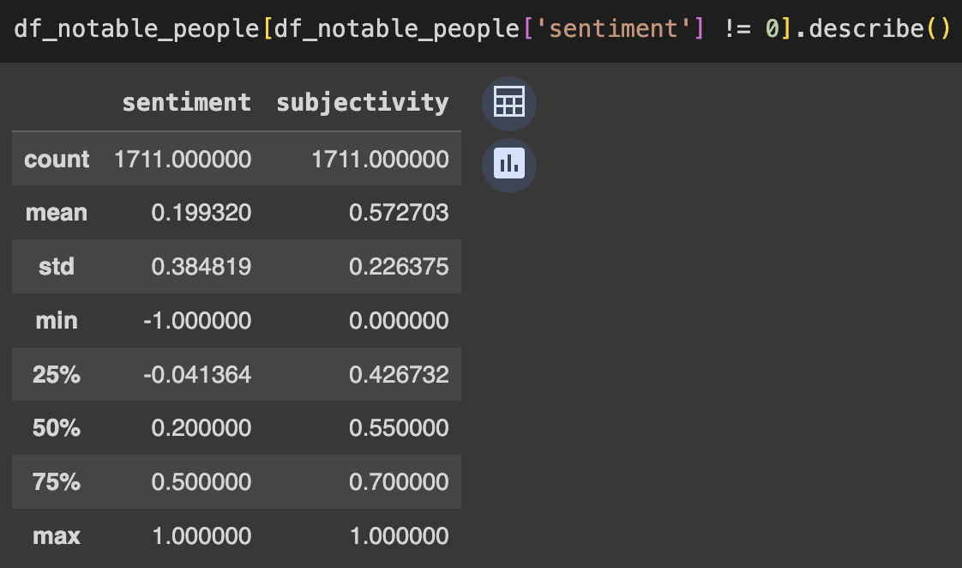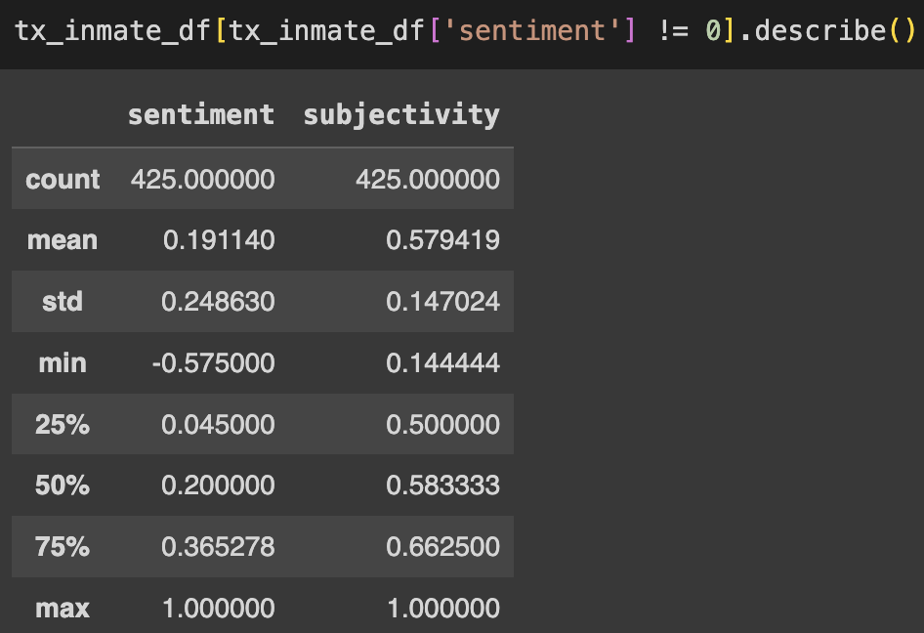

Our statistical analysis of sentiment and subjectivity further underscores the structural differences between the groups. The mean sentiment score for notable people’s last words is slightly higher at 0.199 compared to 0.191 for inmates, indicating a generally positive tone across both groups. Both groups have a median sentiment around 0.2, reflecting a similar central tendency toward mildly positive expressions. However, the sentiment range for notable people spans from -1 to 1, suggesting a wider variety in emotional tone—from deeply negative to highly positive expressions—which likely reflects the diverse public contexts in which these final words were spoken. By contrast, the narrower range of sentiment scores for inmates (from -0.575 to 1) reflects a more moderated tone, clustering around the positive median.

Subjectivity scores also reveal structural distinctions between the groups. The mean subjectivity for notable people’s last words is 0.573, closely aligned with that of inmates at 0.579, suggesting that both groups tend towards subjective, personal expressions. However, the standard deviation in subjectivity for notable people (0.226) is higher than for inmates (0.147), indicating that notable people’s last words vary more widely in emotional depth. This variation could reflect the broader contexts in which these statements were made, with some notable individuals expressing deeply personal sentiments while others offered more philosophical or generalized reflections. The histograms of subjectivity scores confirm these distinctions, with notable people’s subjectivity scores displaying a broader spread, while inmates’ scores are more consistently concentrated.

In summary, these visualizations and statistical analyses reveal distinct structural characteristics in the data: notable people’s final words are marked by a broad range of sentiment and subjectivity, reflecting their varied public contexts, while inmates’ final words show a more personal, consistent tone focused on relationships and regret. Through the combined use of word frequency analysis, sentiment statistics, and visualizations, we gain insight into the differing emotional landscapes each group occupies as they face mortality.

*Initial Inferences*

The exploratory data analysis (EDA) of last words from notable people and inmates reveals distinct thematic and emotional patterns. Notable individuals often focus on existential themes, evidenced by words like “god,” “lord,” and “life,” suggesting a tendency to reflect on philosophical beliefs or religious sentiments. Their broader range of sentiment—from highly positive to deeply negative—indicates varied emotional expression, likely influenced by the more natural or symbolic context of their final moments.

In contrast, inmates’ last words center on personal connections, featuring terms like “love,” “family,” “sorry,” and “thank,” which point to expressions of regret, forgiveness, and appreciation for loved ones. Unique terms like “warden,” “system,” and “momma” hint at their prison experiences or social commentary, suggesting a more intimate focus shaped by their immediate circumstances. The moderate range of sentiment and subjectivity in inmates’ final words reflects a more consistent, restrained tone, likely influenced by the structured environment of executions.

The sentiment analysis supports these thematic differences, with notable people showing greater sentiment variability. Their final words, often public or historical, span a range from defiant to reflective, allowing for a spectrum of emotional expression. Inmates, however, demonstrate more restrained sentiment, focusing on closure or redemption rather than symbolic legacies.

**These observations align with our hypotheses and suggest that the context surrounding death shapes emotional tone. Notable figures, likely influenced by their public status, exhibit a broad range of sentiment, from highly positive to deeply negative, as they reflect on their lives and legacies. Inmates, however, show a narrower range of sentiment, often focused on personal connections and redemption, possibly shaped by the structured environment of death row.**

An emerging hypothesis is that context shapes the emotional tone of last words: notable people, often with more control over their statements, use their final words to express diverse reflections on life and legacy. Inmates, constrained by the controlled execution environment, tend toward intimate, focused expressions aimed at personal closure. These insights suggest that both personal circumstances and social context influence the themes and emotional tones of last words, warranting further analysis of potential subgroups within each dataset to uncover deeper psychological or cultural patterns.

*Conclusion*

Our study highlights the unique psychological and emotional dimensions in the last words of executed prisoners versus notable figures. Notable individuals often express philosophical or existential reflections, while inmates focus on personal connections, regret, and forgiveness. Using Natural Language Processing (NLP) tools, we found that notable figures tend to show a broader range of sentiment and variability in subjectivity, likely shaped by the public nature of their lives. In contrast, inmates’ statements are more moderate and consistent, focusing on closure with loved ones.

Future research could expand on these findings by examining last words across different subgroups (e.g., notable individuals by profession or inmates by crime type). Additionally, a cultural or historical analysis of sentiment could reveal shifts in societal values over time, further contextualizing the emotional patterns in final statements. Finally, including a discussion of methodological challenges, such as data limitations and ethical considerations, would enhance transparency and guide future studies in this area.

These findings suggest that the context of death influences the tone and themes of final statements. Future research could delve further into cultural and situational subgroups, deepening our understanding of how life experiences and context shape individuals' last words. This analysis ultimately offers a meaningful view into how people confront mortality, shaped by their values and circumstances.